# Understand Trading Signals

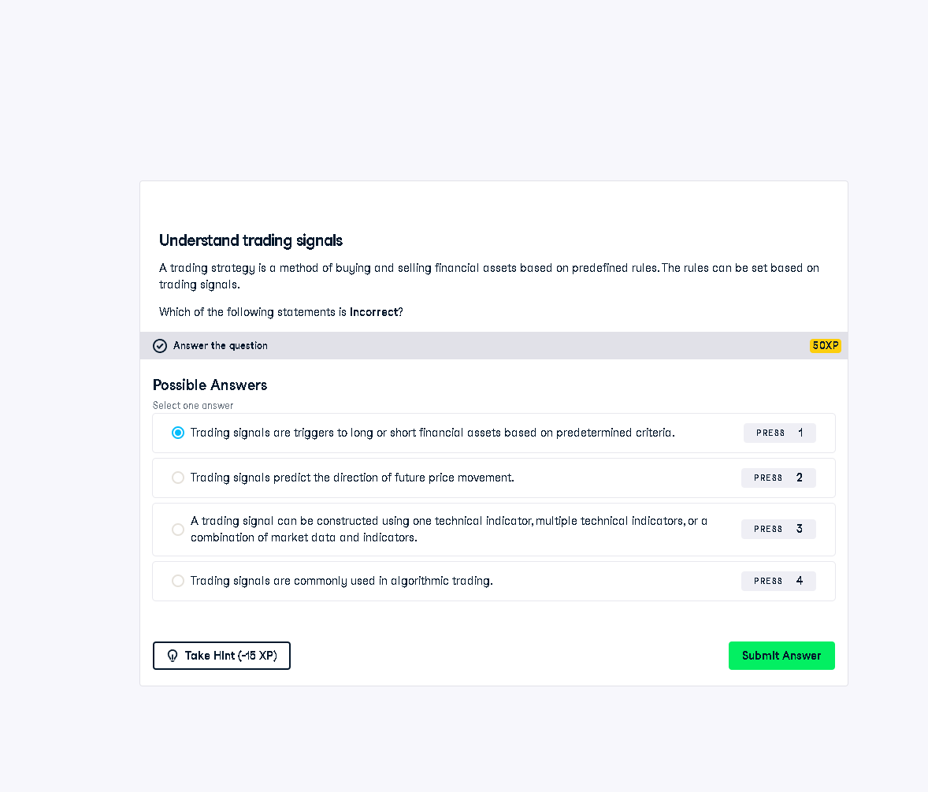

## Full Answer

This question asks which statement is incorrect about trading signals. The incorrect statement is:  
  
"Trading signals predict the direction of future price movement."  
  
This is false because trading signals do not guarantee or predict future price direction; they are tools based on historical data or predefined criteria that suggest potential actions, not predictions.  
  
Correct statements:  
- Signals trigger actions (buy/sell).  
- Signals can be based on technical indicators or combinations.  
- They are widely used in algorithmic trading.

## 50-Word Simple Explanation

Trading signals are not predictions; they suggest what to do based on past data or rules. Saying they “predict” price direction is wrong. Instead, they guide actions (like buy/sell) based on market indicators or algorithms. That’s why the second option is incorrect—it overstates their power.